**National 4 Biology CELL BIOLOGY Unit Assessment Revision**

**CELLS, CELL DIVISION & DNA**

Cells carry out cell division, or mitosis, for growth, and to repair damaged cells.

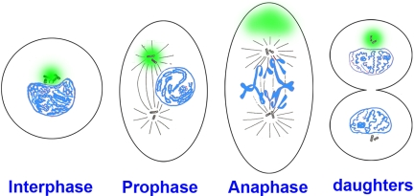

Chromosomes are spindle fibres form chromosome line the cytoplasm divides

seen in the nucleus up along the middle the nuclear membrane forms

of the cell and 2 cells are produced

Sometimes, our cells cannot stop dividing. When cells divide uncontrollably, a tumour can form, and this can lead to cancer.

If a cell divided every 30 minutes, after 1 hour there would be 2 cells. After 2 hours there would be 8 cells.

* If a cell divided every 20 minutes, how many cells would be produced after

1. 1 hour?

b) 2 hours?

Inside the nuclei of our cells are chromosomes. On the chromosomes are genes, and genes are made up of DNA. DNA carries the code to make proteins. To make a protein, DNA carries the code to make amino acids, and then amino acids are built up into proteins. Different proteins are made up of different sequences of amino acids.

Sometimes, our genes can be faulty or damaged, which means that the correct protein cannot be made. Faulty genes can be inherited from parents to children, which is how genetic diseases can run in families.

Our DNA is unique. In forensic science, DNA can be collected from crime scenes, and can prove that someone committed a crime if the sample found at a crime scene matches a suspect’s DNA.

**BAR GRAPHS**

When drawing bar graphs, always remember to complete the scales on both axes, label both axes with the units, and check you have plotted the bars correctly. When reading information from a bar graph, look at the scale very carefully. Try the example below:

* The graph below shows the percentage of stain removed by three different washing

powders (X, Y and Z) when used at different temperatures.



* Which washing powder works best at 30oC?
* Which washing powder works best at 70oC?

**GENETIC ENGINEERING, STEM CELLS AND GENE THERAPY**

Stem cells can be used to research many diseases or new treatments, and could even be used in the future to help cure very serious medical conditions e.g. Alzheimers

Gene therapy is when an abnormal gene (that could cause e.g. cancer) is removed and replaced with another gene. Some people think that this is messing with people’s DNA, and something could go wrong, so is a controversial procedure.

In genetic modification (or genetic engineering), enzymes are used to cut out a gene. A plasmid is taken from a bacterial cell, cut open and the gene is inserted. The altered plasmid is then replaced into the bacterial cell. The bacteria grow and divide, which will make the bacteria produce the protein coded for by the inserted gene. Insulin, hormones or other proteins, including enzymes, can be made using genetic engineering.

* Write the stages of genetic engineering in order:

1. ______________________________________________________________
2. ______________________________________________________________
3. ______________________________________________________________
4. ______________________________________________________________
5. ______________________________________________________________

**ENZYMES**

Enzymes are biological catalysts. They speed up chemical reactions, but are not used up in the reaction. Enzymes are specific – they only work on one substance e.g. amylase only works on starch.

**MICROORGANISMS**

Many microorganisms are used in the food industry – these include yeast (which makes bread, beer and wine) and bacteria (which make cheese and yoghurt).

To make cheese an enzyme called rennet is used. Rennin turns milk into curds and whey. Curds are then used to make cheese. To make yoghurt, bacteria are added to milk, which makes it go a little sour. Bacteria can also be genetically engineered to make enzymes, which can then be added to biological detergents. Non-biological detergents do not contain enzymes – they have other chemicals added to help remove dirt and stains.

* Which box contains TWO products made by YEAST?



* What is added to milk during yoghurt making?
* What is a biological detergent?

**PHOTOSYNTHESIS**

A limiting factor will limit the rate of photosynthesis, and how much starch is being produced. **Li**ght intensity, temperature and carbon dioxide concentration can all affect the rate of photosynthesis. At low light intensity (S), the rate of photosynthesis will be low. When light intensity is increased (T), the rate of photosynthesis will increase.



High light intensity, high rate of photosynthesis

Low light intensity, low rate of

photosynthesis

**RESPIRATION**

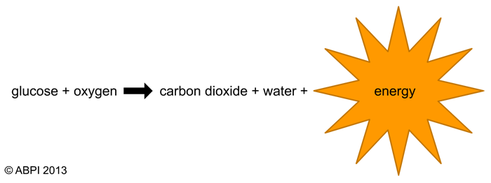Respiration is when our cells use up food (glucose) and oxygen to release energy. We also make two waste products during respiration – carbon dioxide and water.

Respiration is controlled by enzymes. Temperature and oxygen concentration will both affect the rate of respiration. When carrying out respiration experiments, only one variable can be changed e.g. the level of oxygen would be kept the same These experiments could also be set up to show that only living cells respire – in this case a dead organism, or glass beads cold be used instead.

**CONTROVERSIAL PROCEDURES**

In PHARMING, plants can be genetically engineered to produce medicines or drugs. Genetic engineering can be used to transfer genes from one organism to another (TRANSGENICS). Both of these are controversial proceduresas these processes do not happen naturally. Scientists alter DNA which could then be passed onto any offspring.

