SUGGESTED ANSWERS

Higher Biology

Problem Solving
Questions
Higher Biology Problem Solving Questions
Marking Scheme

Section A

QUESTION | QUESTION USED | ANSWER
1 | 3 (RH 2013) | C
2 | 7 (RH 2013) | B
3 | 8 (RH 2013) | C
4 | 11 (RH 2013) | B – graph!!!
5 | 18 (RH 2013) | B
6 | 26 (RH 2013) | A
7 | 29 (RH 2013) | D
8 | 2 (RH 2012) | B
9 | 5 (RH 2012) | B
10 | 13 (RH 2012) | C
11 | 14 (RH 2012) | B
12 | 17 (RH 2012) | A
13 | 26 (RH 2012) | C
14 | 30 (RH 2012) | C
15 | 8 (Specimen Paper) | C
16 | 10 (Specimen Paper) | D
17 | 12 (Specimen Paper) | A
18 | 7 (Higher 2013) | D
19 | 6 (Higher 2013) | B
20 | 16 (Specimen Paper) | C
21 | 15 (Higher 2013) | A
22 | 24 (Higher 2013) | C
23 | 25 (Higher 2013?) | B
24 | 8 (Higher 2012) | C
25 | 17 (Higher 2012) | B

Section B

Q1 (Q4 2013 RH)
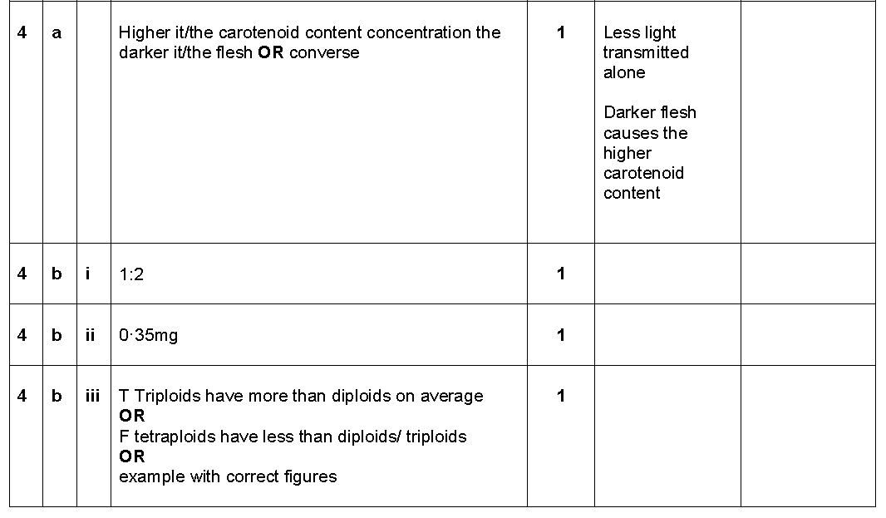

Q2 (Q5a 2013 RH)

Q3 (Q8 2013 RH)
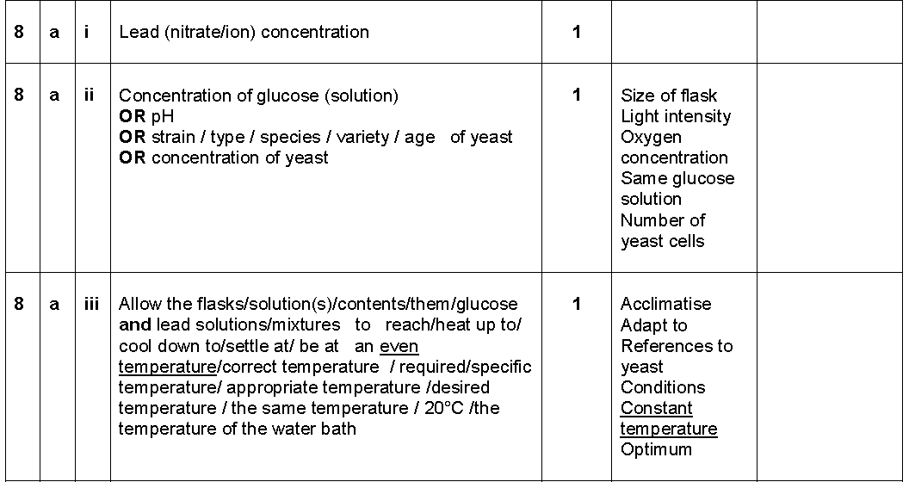
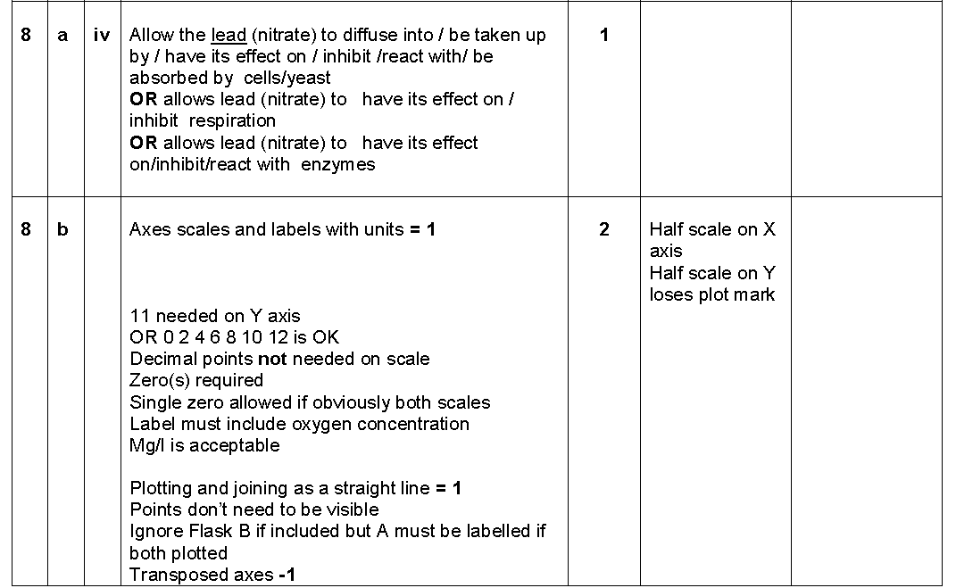
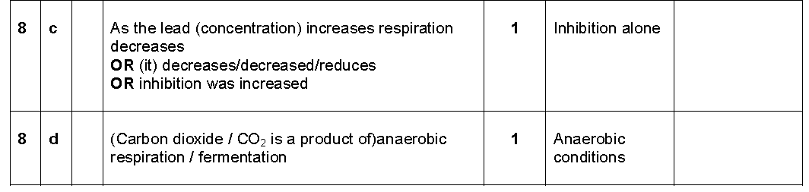

Q4 (Q9a-c 2013 RH)
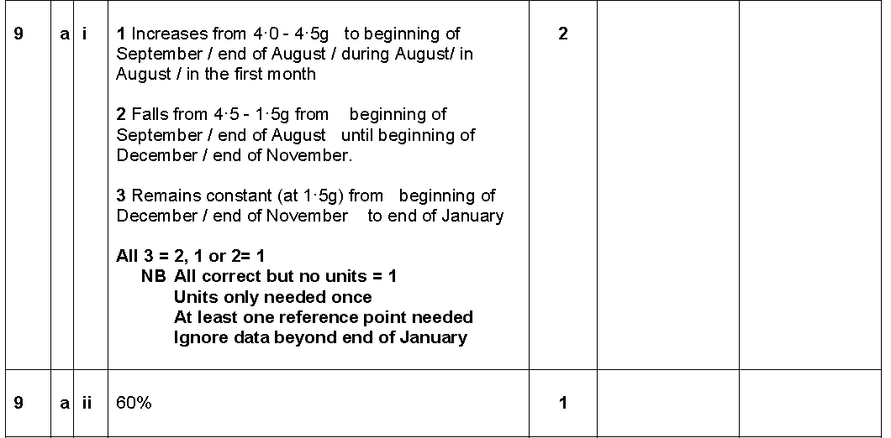
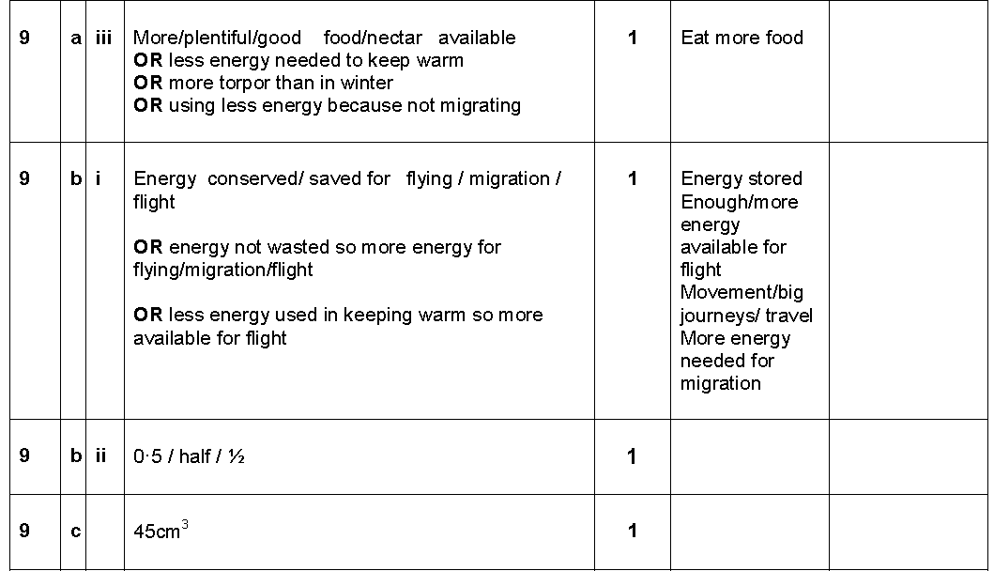

Q5 (Q13a-c(i) 2013 RH)
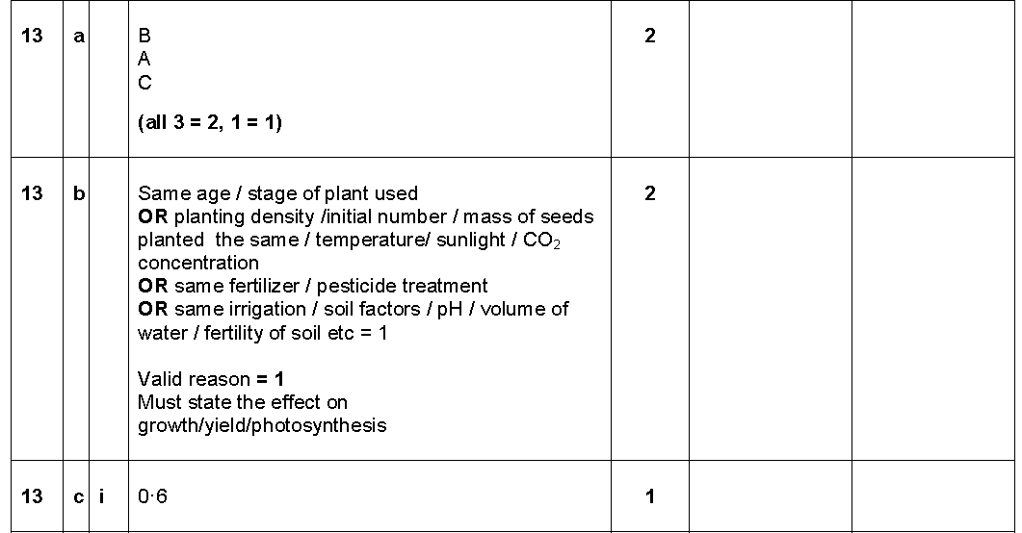

Q6 (Q15a-c 2013 RH)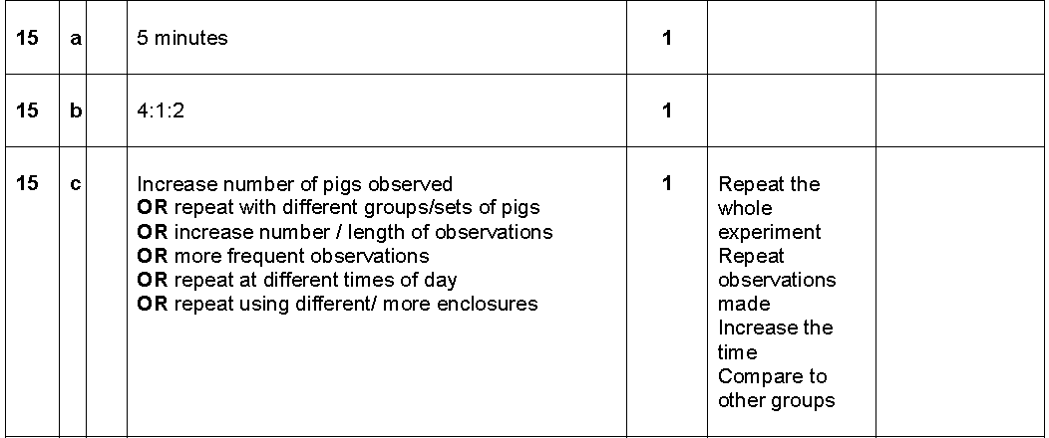

Q7 (Q5 2012 RH)
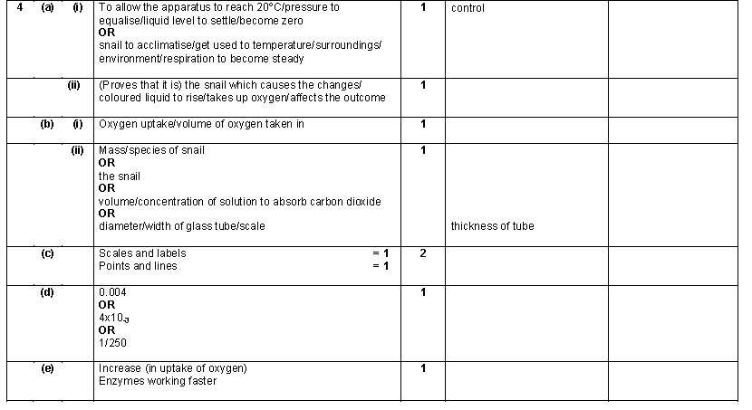
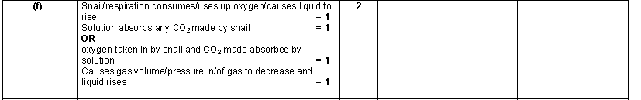

Q8 (Q9 2012 RH)
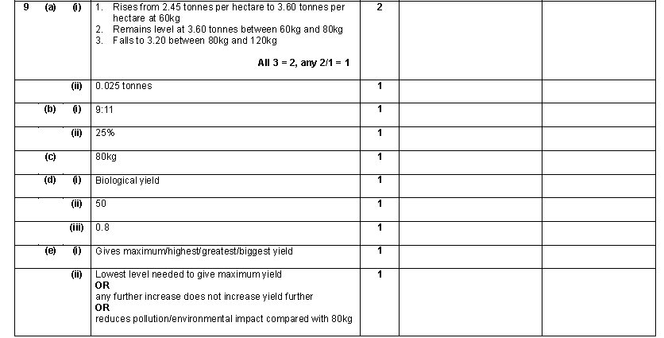
Q9 (Q2b(ii) Specimen Paper)
Q10 (Q4c(i) Specimen Paper)

Q11 (Q6 Specimen Paper)
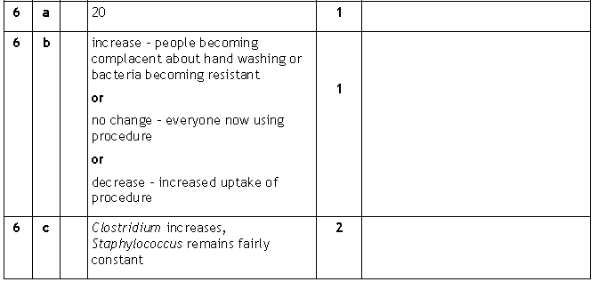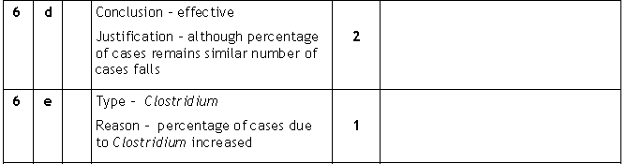
Q12 (Q9a&b Specimen Paper)
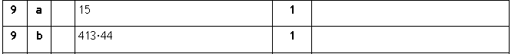

Q13 (Q10 Specimen Paper)
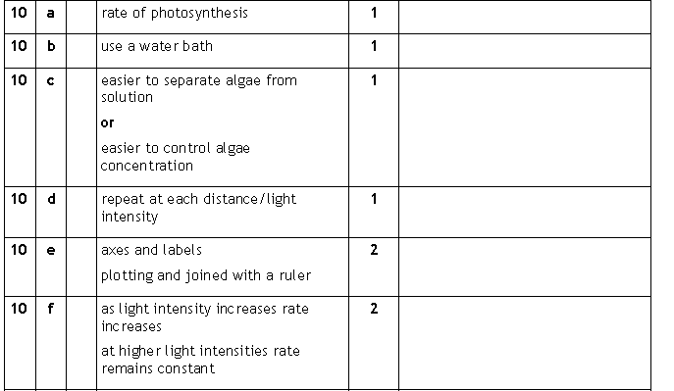
Q14 (Q11b Specimen Paper)
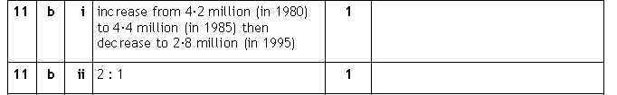
Q15 (Q2aiii & iv 2013 Higher)

Q16 (Q4a-c 2013 Higher)
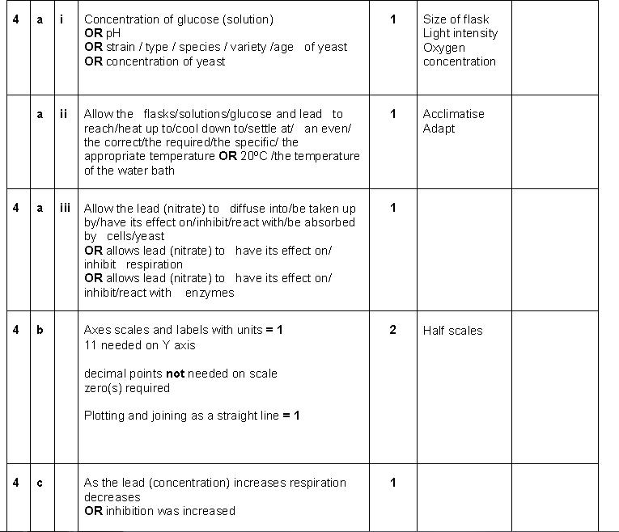
Q17 (Q10ai & ii 2013 Higher)
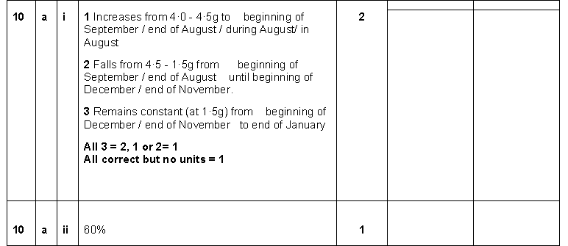

Q18 (Q11 a&b 2013 Higher)
Q19 (Q12a 2013 Higher)
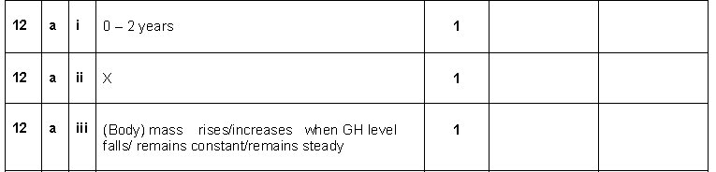
Q20 (Q20 2012 Higher)
