National 4 Biology Life on Earth Unit Assessment Revision

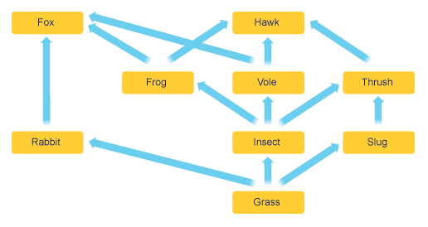
In a food web, animals depend on the other animals and plants that they eat for food.

Food webs are made up of many different food chains linked together
For example, one food chain from the food web above is:
GRASS RABBIT FOX
- Can you find three more?
_____________________________________________________________________
_____________________________________________________________________
_____________________________________________________________________
Food webs are delicately balanced. If one organism is removed from a food web, the other animals and plants in the food web can also be affected. Some animals may DECREASE due to a lack of food. Some animals or plants may INCREASE because there are less animals eating them.
In the food web above, if the slugs were all removed, then the thrush numbers would DECREASE due to a lack of food. The numbers of grass could INCREASE as they are no slugs eating it.
- What could happen if the frogs were removed?
Fox numbers would _____________________________________________
Thrush numbers _______________________________________________
Insect numbers would ___________________________________________

Biodiversity is the total variety in all the species of plants and animals in an area.
Many human activities can affect the biodiversity in an area.
- Give a description of each of the following examples:
- Habitat destruction _______________________________________________________
- Over-fishing _______________________________________________________
- Deforestation _______________________________________________________
- An oil spill _______________________________________________________

- How would each of the examples above affect biodiversity? What would happen to the variety of species in an area if these activities happened? Why would this happen?
_____________________________________________________________________________________________________________________________________________________________________________________________________________________________________________________________________________________________________________________________________________________________________________________________________________________________
The nitrogen cycle is an important way to allow nitrogen to be built up into proteins. Animals get their nitrogen from eating other plants or animals. Plants get their nitrogen by absorbing it from the soil in their roots.
Farmers need to make sure that their crops have enough nitrogen for growth. Framers can add manure, or other fertilisers to soil to give the plants a supply of nitrogen. Some plants like peas, beans and clover have a lot of nitrogen in their roots. These plants are very good at adding nitrogen to the soil.

If plants don’t get enough nitrogen, they would only be able to grow very slowly, or might not grow at all.
- If you were a farmer, what would you do to make sure that your fields and plants always had enough nitrogen?
__________________________________________________________________________________________________________________________________________

Animals and plants often have special adaptations to let them live in harsh conditions. Deserts are very warm, the Artic is very cold, rainforests have a lot of rain; so adaptations will help plants and animals to survive in these areas.
- Name an animal that has adaptations for the following:

- Broad feet to stop them sinking into the sand ____________________
- Good eyesight to hunt prey __________________________________
- Good hearing to listen out for predators ________________________

In birds, the shape and size of their beak is matched to the type of food they eat.
- Very small beaks will be used to eat small insects or seeds.
- Birds with sharp pointed beaks will often eat other animals.
- Birds with very large beaks can eat a lot of fish very easily.

- Can you think of some examples for each?
1___________________________________________________________
2___________________________________________________________
3___________________________________________________________

When completing experiments, the results that we collect give us important information. You should be able to see any difference between the results in an experiment.
Height of plant (cm) | Number of leaves
30 | 25
40 | 40
60 | 80

- What can you say about the number of leaves as the height of the plant increases?
_____________________________________________________________________
_____________________________________________________________________

In Biology, when looking at the results of an experiment, we can also be asked to calculate a ratio. This means comparing one number with another, but the numbers have to be WHOLE numbers, and simplified, and cancelled down.
For example, in a class of 10 girls and 2 boys, the ratio would be 2 girls : 1 boy (as there are twice as many girls as there are boys).
Work out the ratio for the number of leaves in the 40cm plant, compared to the 60 cm plant.

_______________________ : ______________________
40 cm 60 cm

