National 4 Biology Life on Earth Unit Assessment Revision Help Sheet
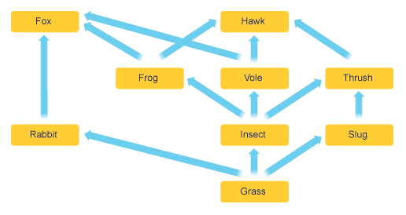
In a food web, animals depend on the other animals and plants that they eat for food.

One food chain from the food web above is:
GRASS RABBIT FOX
Complete the following food chains:
GRASS __________________________ VOLE HAWK
_________________ SLUG THRUSH __________________
GRASS INSECT _________________ FOX
If one organism is removed from a food web, the other animals and plants in the food web can also be affected.
In the food web above, if the slugs were all removed, then the thrush numbers would DECREASE due to a lack of food.
The numbers of grass could INCREASE as they are no slugs eating it.
- What could happen if the frogs were removed?
Fox numbers would INCREASE / DECREASE because _____________________________________________________________________
Thrush numbers INCREASE / DECREASE because _____________________________________________________________________
Insect numbers would INCREASE / DECREASE because _____________________________________________________________________

Biodiversity is the total variety in all the species of plants and animals in an area.
Many human activities can affect the biodiversity in an area.
In the examples below, match what is meant by each term:
- Habitat destruction catching more fish than needed
- Over-fishing oil being released into the sea
- Deforestation destroying the homes of animals
- An oil spill cutting down too many trees
All of these would DECREASE biodiversity as the numbers of animals and plants would DECREASE

The nitrogen cycle is an important way to allow nitrogen to be built up into proteins.
Animals get their nitrogen from eating other plants or animals.
Plants get their nitrogen by absorbing it from the soil in their roots.
Framers can add manure, or other fertilisers to soil to give the plants a supply of nitrogen.
Plants like peas, beans and clover are very good at adding nitrogen to the soil.
If plants don’t get enough nitrogen, they would only be able to grow very slowly, or might not grow at all.

Animals and plants often have special adaptations to let them live in harsh conditions.
- A CAMEL has broad feet to stop it sinking into the sand
- EAGLES have good eyesight to hunt prey
- DEER have good hearing to listen out for predators

In birds, the shape and size of their beak is matched to the type of food they eat.
- Very small beaks will be used to eat small insects or seeds e.g a CHAFFINCH
- Birds with sharp pointed beaks will often eat other animals e.g a HAWK
- Birds with very large beaks can eat a lot of fish very easily e.g a PELICAN

When completing experiments, the results that we collect give us important information. You should be able to see any difference between the results in an experiment.
Height of plant (cm) | Number of leaves
30 | 25
40 | 40
60 | 80

Complete the following conclusion:
As the height of plant INCREASES / DECREASES, the number of leaves INCREASES / DECREASES.
In Biology, when looking at the results of an experiment, we can also be asked to calculate a ratio.
This means comparing one number with another, but the numbers have to be WHOLE numbers, and simplified, and cancelled down.
For example, in a class of 10 girls and 2 boys, the ratio would be 2 girls : 1 boy (as there are twice as many girls as there are boys).
Work out the ratio for the number of leaves in the 40cm plant, compared to the 60 cm plant.

_______________________ : ______________________
40 cm 60 cm

