**N5 Biology Multicellular Organisms Unit Revision Summary**

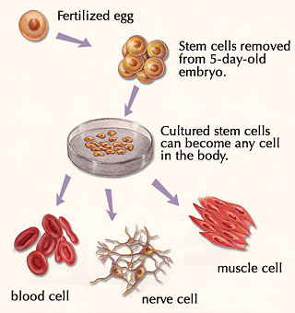

Stem cells are unspecialised cells found in certain locations in an animals body. Stem cells can be used to replace body organs, or repair damaged tissues e.g the heart. They can also be used to produce skin grafts. There are ethical issues when it comes to stem cells, as many stem cells are collected from embryos.

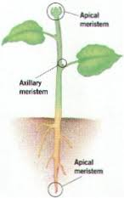Meristems are found in plants, at the root tips and shoot tips. Meristems are the sites of cell division in plants, and where unspecialised cells are produced. At a later stage, these unspecialised cells can then become specialised into e.g. new xylem or phloem tissue.

Lateral meristem

Apical meristem

Apical meristem

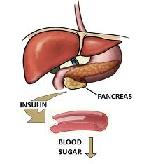They are many glands in the body which produce hormones – these glands are called endocrine glands. Examples include the pituitary gland, the adrenal glands, the thyroid gland and the pancreas. The pancreas controls blood sugar levels by producing the hormone insulin. Insulin converts glucose into glycogen, which is then stored in the liver. Another hormone, glucagon, converts glycogen into glucose when needed.

* Label the liver
* What other hormone controls blood sugar levels?
* What substance is stored in the liver?

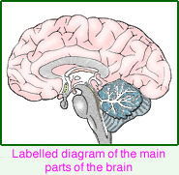There are three parts of the brain – the cerebrum, the cerebellum and the medulla. The cerebrum is the largest part of the brain and controls all of our conscious thoughts, including memory, personality and intelligence. The cerebellum controls balance and muscular co-ordination. The medulla controls involuntary actions such as heart rate, breathing rate and swallowing.

* Label the parts of the brain

Nerve cells are also known as neurons. Neurons carry nerve impulses to and from our central nervous system (CNS). A stimulus is detected by receptors in our sense organs. This then sends an impulse along a sensory neuron to the CNS. Realy neurons in the CNS then pass an impulse along a motor neurn to the effectors (usually a muscle) to carry out an appropriate response.

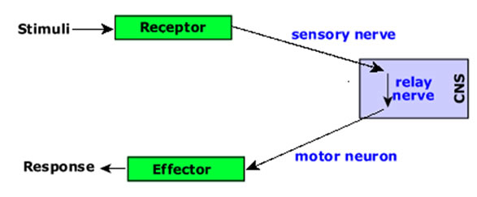

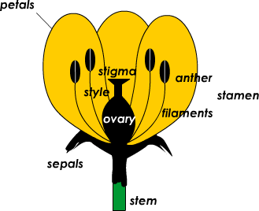Sex cells are also known as gametes. Gametes are produced in sex organs in both plants and animals. In animals, the sex organs are the testes and the ovaries. Sperm are produced in the testes and ova (eggs) are produced in the ovaries. Sperm cells are specialised cells in males. They have a tail which allows them to swim or move towards the female sex cell to achieve fertilisation.

In plants, pollen (the male gamete) is produced in an anther and ovules (the female gamete) are also produced in the ovary.

* Which parts of the flower are

1. Male?

b) Female?

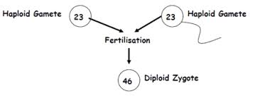Gametes are haploid cells, and contain only one set of chromosomes. Other cells are diploid, and contain two sets of chromosomes. At fertilisation, haploid gametes fuse to form a zygote (a fertilised egg cell). Zygotes are diploid cells as they contain two sets of chromosomes (one set from each parent).

Variation is the differences that occur between individuals in a population or species.

There are two types of variation – discrete and continuous. Discrete variation is clear cut, observed and can be split into distinct groups. Examples include eye colour, hair colour, blood group etc. Continuous variation is wide ranging and is often measured e.g. height, weight, pulse rate etc.

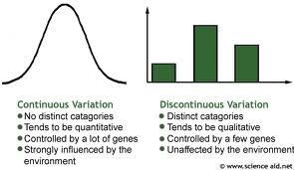

Many characteristics are controlled by more than one gene (e.g. height, skin colour). This type of inheritance is called polygenic inheritance.

There are many physical differences between organisms. The physical appearance of an individual is known as the phenotype. Each characteristic is controlled by at least two genes. The genes that an organism possesses is usually written using letters (e.g. Bb), and is known as the genotype.

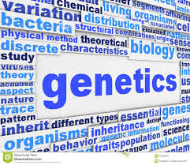Organisms who are true breeding are known as homozygous. Organisms with different genes (e.g. one dominant gene and one recessive gene) are celled heterozygous – and are not true breeding.

Different forms of the same gene are called alleles.

Look at the information below:



Transpiration is the movement of water from the roots of a plant up to the leaves. Water is required in a plants leaves for photosynthesis. Light intensity, temperature and humidity can affect transpiration rate.

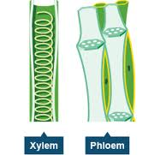Xylem tissue and phloem tissue are found in plants. Xylem carries water and minerals from the soil up to the leaves of plants. They are hollow, and supported by rings of lignin. Phloem carries dissolved sugars from the leaves of a plant, down and all over to cells that require it. Phloem contains strands of cytoplasm, and sieve tubes and sieve plates. The sieve plates contain pores to allow the transportation of sugars. They also contain companion cells, with a large nucleus, to control the phloem cells and also provide energy for the transport of sugars.

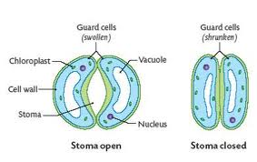Water vapour is lost in plants leaves through small pores known as stomata. Stomata are found on the lower leaf epidermis.

Guard cells surround the stomata and control the opening and closing of the stomata. Water enters guard cells, making the cells turgid and causing them to open the stomata. When water is lost from guard cells the cells become flaccid, and the stomata close.

When the stomata are open, this allows the exchange of gases (oxygen and carbon dioxide) from the atmosphere and the cells.

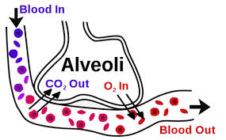Gas exchange also occurs in animals, through the respiratory system. Air enters our nose and mouth and enters the trachea or windpipe. The trachea has rings of cartilage to hold it open, which prevents suffocation. The trachea then leads to the bronchi, bronchioles and into the air sacs or alveoli. Air sacs have a one cell thick lining, are moist, have a good blood supply and a large surface area to increase gas exchange.

Oxygen dissolves in the lining of the air sacs and passes into the blood stream by diffusion. Carbon dioxide diffuses from the blood, into the air sacs to be breathed out.

The respiratory system is lined with a sticky fluid called mucus. Mucus traps dirt and germs, and then this dirty mucus is swept up and out of the lungs by tiny hairs called cilia.

Our circulatory system is made up of the heart and blood vessels. The heart pumps blood out through the body , through arteries, into capillaries, then is returned to the heart by the veins.

Arteries are thick and muscular, as they carry blood under high pressure. Most arteries carry oxygenated blood to the cells and tissues. There, many capillaries allow oxygen and dissolved food to diffuse out of the blood into cells, and carbon dioxide and other wastes (e.g. urea) diffuse out of the cells back into the blood.

To allow the substances to diffuse, capillary networks are thin walled and have a large surface area. Blood then returns to the heart in veins. Veins have thinner walls than arteries, and are less muscular, as they carry deoxygenated blood under low pressure. To prevent the backflow of blood, veins also contain valves.

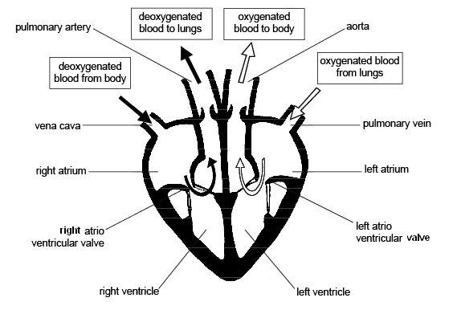The heart is a muscular pump made up of four chambers – two atria and two ventricles. The atria are collecting chambers, the ventricles are the chambers that pump blood. The right hand side of the heart receives deoxygenated blood from the body, into the right atrium. The right ventricle then pumps blood to the lungs , where it combines with oxgen. Oxygentaed blood then returns to the left hand side of the heart, into the left atrium. The left ventricle then pumps blood out through the main artery, the aorta.

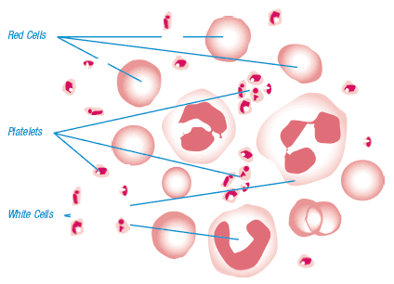

Blood contains red blood cells, white blood cells, plasma and platelets. The plasma is a liquid that carries the blood cells and dissolved substances around the boy. Red blood cells are biconcave in shape to increase their surface area. They contain haemoglobin, which carries oxygen round the body. White blood cells fight disease and infection. Platelets clot the blood at wound sites.

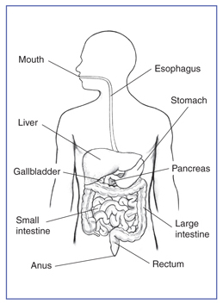The digestive system in animals allows the digestion of large, insoluble molecules of food, into small soluble molecules.

* What are the functions of the main parts of the digestive system?

1. stomach…
2. liver…
3. gall bladder…
4. pancreas…
5. small intestine…
6. large intestine…

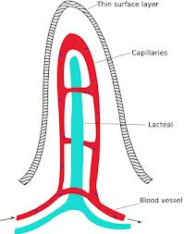Most of this digestion occurs in the small intestine, due to the presence of enzymes as well as small finger like projections called villi. Villi have a one cell thick lining, a good blood supply and a large surface area to increase the absorption of dissolved food into the blood or the lymph fluid. Glucose and amino acids will be absorbed into the blood capillaries, where the products of fat digestion are absorbed into the lymph fluid, and transported via the lymphatic system.

In Scotland, there are increasing numbers of the population suffering from heart disease. Heart disease is also a contributing factor to high blood pressure, type 2 diabetes, having a stroke or a heart attack. Medically, heart disease can be reduced greatly by modifying diet. Other factors which may reduce the risk of heart disease include losing weight, stopping smoking, cutting down on alcohol and exercising regularly.

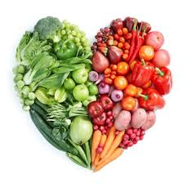

* What do we mean by modifying our diet? Give examples.

The benefits of exercise are well known. Exercise increases the efficiency of the heart and the lungs. The heart will be much stronger, as the cardiac muscles increases. This allows more blood to be pumped with each beat, so the heart will beat less often (so heart rate decreases). In the lungs, there is an increased volume of air per breath, an increase in the number and diameter of capillaries on alveoli and the respiratory muscles increase in strength. This will allow more oxygen to diffuse into the blood, and be carried to respiring cells.